Zkontroluj si – U 4 (FOOD)
1.Zeptej se kamaráda, jestli má rád :
- Máš rád jablka?____Do you like apples? ________

- Máš rád banány? ____Do you like bananas?______

- Máš rád sušenky? ___Do you like biscuits? ______

- Máš rád brokolici? ___Do you like broccoli? _____

- Máš rád dort? ______Do you like cake?________
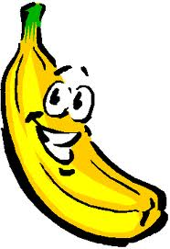
+ 2.odpověz za sebe – možné odpovědi:
- Yes, I do. (Ano, mám.)
- No, I don´t. (Ne, nemám.)

3.Dopiš ve větách, zda máš nebo nemáš rád:

Kuře | I like chicken.  I don´t like chicken.
Hranolky | I like chips.  I don´t like chips.
Čokoládu | I like chocolate.  I don´t like chocolate.
Zmrzlinu | I like ice cream.  I don´t like ice cream.
Mléko | I like milk.  I don´t like milk.
Houby | I like mushrooms.  I don´t like mushrooms.
Těstoviny | I like pasta.  I don´t like pasta.
Hrušku | I like pear.  I don´t like pear.
Pizzu | I like pizza.  I don´t like pizza.
Brambory | I like potatoes.  I don´t like potatoes.
Papriky | I like peppers.  I don´t like peppers.

+ Zkus si objednat pizzu:
Can I have a pizza, please?
*** Yes, of course. Do you want mushrooms?
Yes, please. I like mushrooms.
*** Do you want peppers?
No, thank you. I hate peppers.
*** And do you want olives?
Yes, please. I love olives.
*** Ok, here you are. 1 pizza with mushrooms and olives for you. Enjoy your food.
Thank you. How much is it?
*** It´s £3,00.
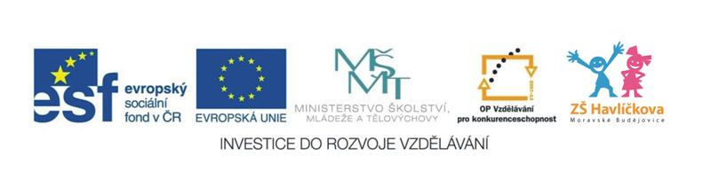
Here you are.
*** Thank you.

