What´s in my bag?

___________________________________________________



What´s in my class?

___________________________________________________

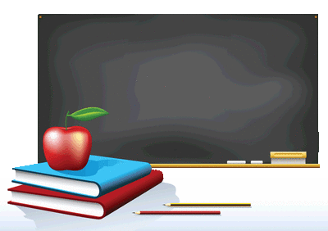

a ruler

a rubber

a pen

a pencil

a book

a chair

a table

a bin

a board

a book



Zdroj: http://www.edupics.com/, http://www.wpclipart.com/