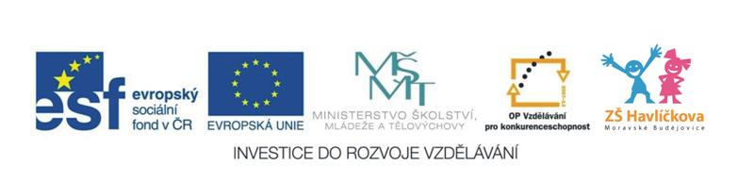
6. Toys (hračky)
A clown, a car, a bike, a train, a house, a rocket, a robot, a teddy, a doll, a ball, a yoyo, a boat, a plane, a drum, a guitar
I´ve got ………. (Já mám …)
Let´s play. (Pojďme si hrát)
****************************
Clown je v angličtině šašek,
Jako česky jásá Vašek,
Car je auto, kočka cat
Tohle budu umět hned.
***************************
What´s in the box? (Co je v krabici?)
**************************
Písnička: Look! I´ve got a robot, a robot, a robot,
I´ve got a robot in my house.
**************************
Písnička: What do you want for Christmas, Christmas, Christmas? What do you want for Christmas?
Santa´s on his way. I want a robot ….

