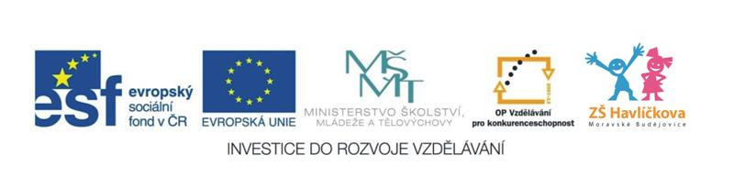
5. Food (jídlo)
apples, bananas, oranges, strawberries,
cake, pizza, fish, chips, hot dog, sandwiches, hamburgers, carrots, biscuits, ice cream, broccoli, soup, pop corn
I like ………… (Mám rád-a ….)
Do you like …….? (Máš rád-a ……..?)
Yes, I do. (Ano, mám.)
No, I don´t. ( Ne, nemám.)
**************************
Písnička: What is in the kitchen? I can smell a pizza. Sniff, sniff, sniff, sniff. Let´s eat now…
Písnička: I like apples. Yami, yami. I like apples in my tummy…
Písnička: Do you like broccoli? Yes, I do. Do you like ice cream? Yes, I do. Do you like broccoli ice cream? No, I don´t, Yak.
+ Dostal jsem chuť na ice cream. Ta dobrota, hned ji sním. Tak zapískám na Olinu, půjdem spolu na zmrzlinu.

