MY FIRST FAIRY TALES – THE LITTLE HOUSE
MOJE PRVNÍ POHÁDKY – BOUDO, BUDKO (kdo v tobě přebývá)
- určeno ke čtení, procvičování a dramatizaci
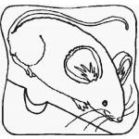
7 characters – mouse, frog, hare, fox, wolf, dog, bear

Read the story:

Mouse - Oh, this is a beautiful house. I´ll live here.
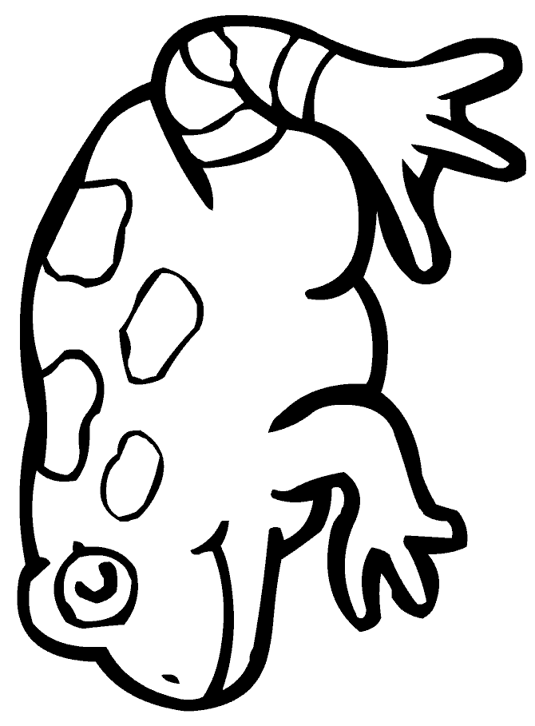
Frog (coming) – (Knock, knock) Little house, little house, who´s inside?
Mouse - Me, a mouse. And who are you?
Frog - I am a frog. Let me in, please.
Mouse - You´re welcome. Come in!

Hare (coming) – (Knock, knock) Little house, little house, who´s inside?
Mouse - Me, a mouse
Frog - Me, a frog. And who are you?
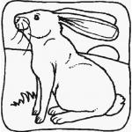
Hare - I am a hare. Let me in, please
M+F – No problem. Come in!

Fox (coming) – (Knock, knock) Little house, little house , who´s inside?
Mouse - Me, a mouse
Frog - Me, a frog.
Hare - Me, a hare. And who are you?
Fox - I am a fox. Let me in, please.
M+F+H – OK. Come in!

Wolf (coming) – (Knock, knock) Little house, little house , who´s inside?
Mouse - Me, a mouse
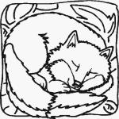
Frog - Me, a frog.
Hare - Me, a hare.
Fox - Me, a fox. And who are you?
Wolf - I am a wolf. Let me in, please.
M+F+H+Fo – OK. Come in!

Dog (coming) – (Knock, knock) Little house, little house , who´s inside?
Mouse - Me, a mouse
Frog - Me, a frog.
Hare - Me, a hare.
Fox - Me, a fox.
Wolf - I am a wolf. And who are you?
Dog - I am a dog. Let me in, please.
M+F+H+Fo+W – OK. Come in!
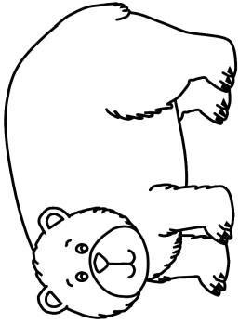
Bear (coming) - (Knock, knock) Little house, little house, who´s inside?
Mouse - Me, a mouse
Frog - Me, a frog.
Hare - Me, a hare.
Fox - Me, a fox.
Wolf - I am a wolf.
Dog - I am a dog. And who are you?
Bear - I am a bear. Let me in, please.
M+F+H+Fo+W+D – OK. Come in!
(the bear pushes into the house, he is too big and the house breaks up)
(medvěd se tlačí do budky, ale je moc velký a budka se rozpadne)

Vocabulary

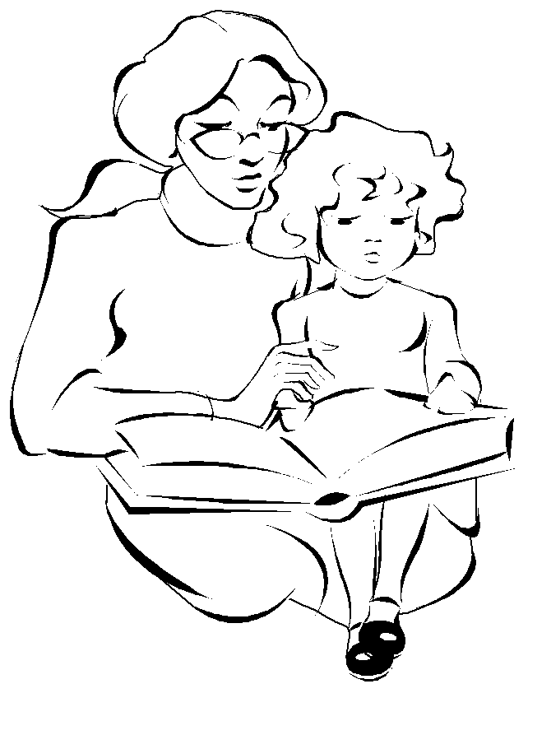
bear - medvěd
frog - žába
hare - zajíc
fox - liška
wolf - vlk
inside - uvnitř
Let me in! - Pusťte mě dovnitř!
Who are you? – kdo jsi?
You´re welcome. – Jsi vítán.

A song „Happy house“ – „Broken house“
It´s a house, it´s a happy house (2x)
Can you see?
Here´s a window.
Here´s a door.
Here´s a roof.
And here´s a floor.
It´s a happy house for you and me!

- Draw a happy house: - Draw a broken house:

