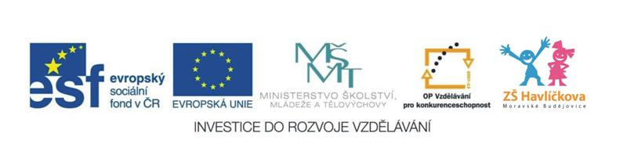
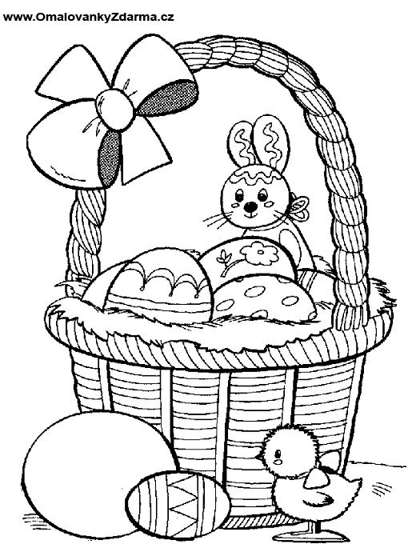
A song: Eggs in the Easter basket
How many eggs in the Easter basket?
1, 2, 3, 4, 5,
5 eggs in the Easter basket,
1, 2, 3, 4, 5,
What colour are the eggs in the Easter basket?
Look at the Easter basket.

Pracovní list k písničce:
- Count (spočítej):
How many eggs are there in the picture? 1 2 3 4 5 6 7 8 9 10
How many eggs are there in the basket? 1 2 3 4 5 6 7 8 9 10

- Listen and colour the picture (poslouchej písničku a vybarvi obrázek):
What colour are the eggs in the Easter basket?
Red yellow blue green black white
brown orange purple pink grey
Happy Easter to you! 