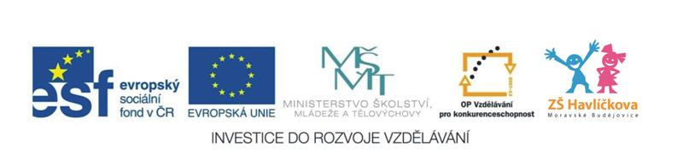

7. Family (rodina):
Mummy, daddy, sister, brother, baby, grandma, grandpa, uncle, aunt
This is my ………. (Toto je moje ….) + family photo
*****************************************************
Písnička: Hello mummy, hello daddy. How are you? Mummy, daddy – I love you. (St Valentine´s card)

