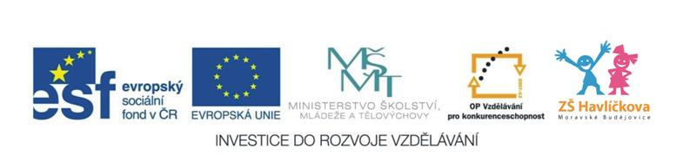

3. + 4. Adjectives (přídavná jména + barvy)
Happy, sad, angry
Big, small = little
Red, yellow, blue, green, black, white, brown, orange, purple, pink, grey
What colour is a ….? (Jakou barvu má ….?)
***************************************
Písnička: Red and yellow, blue and green, …,
black and white and brown.
Orange, purple, pink and grey, …, black and white and brown.

